Drug Abuse and Drug Addiction
Substance use disorders are a class of psychological disorder in which a person continues to use a substance, despite having significant health, social, or other negative consequences because of their substance use.¹

What is a substance, anyway?
In the context of substance use disorders, substances are groups of drugs that have similar effects on your brain, body, and behavior. There are 10 classes of substances considered when diagnosing a substance use disorder:
- Alcohol: beer, wine, liquor
- Caffeine: coffee, tea, kola nut
- Cannabis: marijuana, hashish, hash oil
- Hallucinogens: phencyclidine (PCP), d-lysergic acid diethylamide (LSD), psilocybin (magic mushrooms), peyote
- Inhalants: inhaled spray paints, markers, glues
- Opioids heroin, prescription pain-killers, methadone
- Sedatives, hypnotics, or anxiolytics: barbiturates, benzodiazepines, antihistamines
- Stimulants: cocaine, amphetamines, other stimulants
- Tobacco: cigarettes, cigars, snuff, chewing tobacco, e-cigarettes
- Other (or unknown)
These groupings aren’t perfectly distinct (many drugs fall into more than one category), but can be helpful in understanding how the characteristics of each drug make it more or less likely to be used in excess.

What makes a substance addictive?
The common characteristic of all addictive substances is that they activate the brain’s reward system, either directly or indirectly.
The primary role of the reward system is to encourage you to satisfy the needs important for survival (eating, drinking, having sex). Although the system itself is complex, it operates on a simple principle: if doing something feels good, you’re more likely to do it again. When your needs are met, a region in the midbrain called the ventral tegmental area (VTA) releases a little surge of the chemical dopamine, which makes you feel satisfaction and pleasure. The VTA sends dopamine to several areas of the brain, including:
- Amygdala: sensing and expressing emotions
- Nucleus accumbens: motor control
- Hippocampus: memory formation
- Prefrontal cortex: attention and planning behavior
These brain regions respond to the dopamine surge in ways that guide your memory, attention, and behavior toward repeating whatever triggered the pleasurable chemical release. The shape and function of your brain literally changes as a result of these reactions!²
Always remember: Cells that fire together (in response to the presence of dopamine) wire together (strengthen their connections, so its easier to fire together in the future).

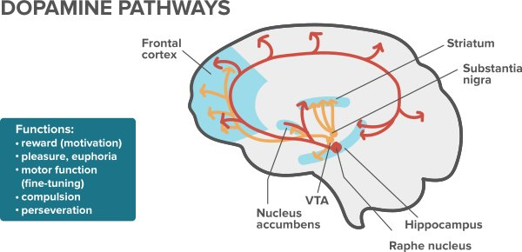
Your reward system doesn’t respond only to your basic needs. As you grow and develop, it also begins to respond to the satisfaction of needs that are important for more abstract goals (like getting a good grade on a test). Any substance that (either directly or indirectly) increases the release of dopamine has the potential to hijack your reward system, making you very motivated to use the substance again. For some people, the motivation for substance use can begin to outweigh the drive to satisfy other needs (getting enough sleep, eating enough, saving money) leading to harmful effects. As a rule of thumb, the relative addictiveness of a drug is measured by the intensity of the effect it has on the release of dopamine.

What are the symptoms of substance use disorders?
It is important to understand the difference between the effects of drug use (intoxication, withdrawal, various physical and psychological health problems) and the unique symptoms of a substance use disorder. The positive and negative consequences of substance use vary greatly depending on the specific drug being used, why and how it is being used, and the characteristics of the user. For this reason, substance-specific consequences are not considered symptoms of a substance use disorder.
The primary features of substance use disorders are a mixture of cognitive, behavioral, and physiological symptoms, which indicate that a person is continuing to use a substance despite significant substance-related problems.¹
Example Substance | Substance-specific negative consequences (not necessarily a sign of substance use disorder) | Substance use disorder
Tobacco | Heart and lung disease | Continuing to use a substance (due to being unwilling or unable to stop) despite having significant negative physical, mental, or social consequences as a result of substance use. This applies to all substances listed.
 | Cancer
 | Lost productivity at work due to needing smoke breaks
 | Turned down for a date because you smoke
Alcohol | Hangover
 | Embarrassing yourself while drunk at a party
 | Intoxication-related injury (falling down, drunk-driving accident, etc.)
 | Liver disease
Cannabis | Problems with work, school, or police as a result of use
 | Intoxication-related injury (falling down, high driving accident, etc.)
 | Depression; lack of motivation
 | Drug-induced psychosis
The symptoms of substance use disorders fall into four categories: impaired control, social impairment, risky use, and pharmacological criteria.

Impaired control over substance use
- Taking a substance in larger amounts or for a longer period of time than was originally intended
- Persistent desire or unsuccessful efforts to cut down or control substance use
- Spending a large amount of time obtaining, using, or recovering from the effects of substance use
- Intense desire or urge to use a substance (craving), especially while in places where the substance was previously obtained or used

Social impairment
- Recurrent substance use resulting in a failure to fulfill duties at work, school, or home
- Continued substance use despite persistent or recurrent social problems caused or made worse by the effects of substance use
- Giving up or reducing important social, occupational, or recreational activities because of substance use

Risky use
- Recurrent substance use in situations where it is physically hazardous
- Continued substance use despite persistent or recurrent physical or psychological health problems likely resulting from substance use

Pharmacological criteria
Experiencing tolerance by either:
- Needing to use an increased amount of a substance to achieve the same effects
- Having diminished effects with continued use of the same amount of a substance
Experiencing withdrawal by either:
- The characteristic withdrawal syndrome for the particular substance (the exact presentation of withdrawal is different for various substances)
- Taking the substance to relieve or avoid the symptoms of withdrawal
To be diagnosed with a substance use disorder, a person must show a problematic pattern of substance use, manifesting in at least two of the above symptoms during a 12-month period. As a general rule, having two to three symptom qualifies as a mild disorder, four to five qualifies as moderate, and six or more qualifies as severe.

What causes substance use disorders?
There is no single cause of substance use disorders. Like most other diseases, there are many factors that influence a person’s vulnerability to developing a substance use disorder.
- Genetics/biological: It is estimated that genes account for 40-60% of a person’s vulnerability to developing a substance use disorder.³ However, this doesn’t mean that there is an addiction gene, but rather that combinations of many genes (as well as other biological factors) may work together to result in a person being more likely to use substances in excess. For example, a person who is biologically predisposed to have a weak dopamine-reward response may be more likely to overuse drugs that cause intense dopamine release.
- Environmental: Growing up in a chaotic home; living in a neighborhood where drugs are easily available; and having family members, friends, or peers who abuse alcohol or other drugs have all been linked to the development of substance use disorders. As is the case with genetic factors, these environmental factors likely do not directly cause a disorder, but instead may increase a person’s vulnerability.
- Developmental: A person’s stage of physical and mental development plays a large role in their vulnerability to developing a substance use disorder. While drug use at any age can be risky, people who begin using drugs before or during adolescence (when the brain is still developing) are at a much higher risk for developing a substance use disorder.

How common are substance use disorders?
Substance use disorders are relatively common, and affect people from all racial, cultural, and economic groups. Worldwide, the estimated prevalence is between 0-16%. Men are more likely than women to be diagnosed with a substance use disorder.

How can you prevent substance use disorders?
Although the exact cause of substance use disorders is unknown, many prevention strategies have been identified. As was mentioned above, initiating drug use at a young age is a huge risk factor for developing a substance use disorder. Research has shown that prevention programs involving families, schools, communities, and health care providers, aimed at educating young people about the risks of drug use, are effective in reducing the prevalence of substance use disorders.

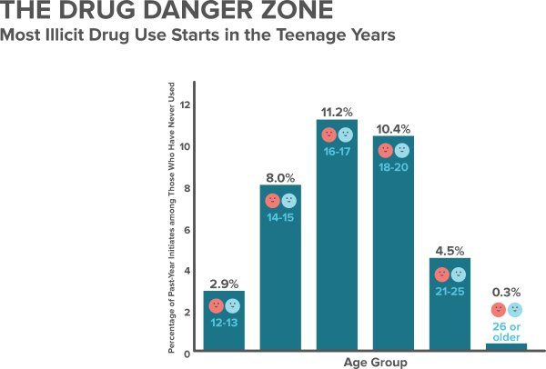

How are substances use disorders treated?
Unfortunately, there is no cure for substance use disorders, but there are several effective treatments. Due to the varied presentation of substance use disorders, treatment is tailored to the specific needs of each person. This treatment can take many forms (12-step meetings, medication support, inpatient rehabilitation, individual therapy), but must be focused on helping the person stop using drugs, maintain a drug-free lifestyle, and actively functioning in society. As substance use disorders are chronic conditions, most people require long-term or recurrent treatment to maintain recovery.

Attribution:
This article is licensed under a CC-BY-NC-SA 4.0 license.

Additional references:
- American Psychiatric Association. (2013). Diagnostic and statistical manual of mental disorders: DSM-5™ (5th ed.)
- Fowler JS, Volkow ND, Kassed CA, Chang L. Imaging the addicted human brain. Sci Pract Perspect 3(2):4-16, 2007.
- National Institute on Drug Abuse. (2014). Drugs, Brain, and Behavior: The Science of Addiction. (DHHS Publication No. 14-5605). Washington, DC: U.S. Government Printing Office.

